1-Page Summary Report: Getting Ready for Physics Class

Problem Statement
A physics teacher needs a compact set of pure Python functions that students can use to convert temperatures (Fahrenheit ↔ Celsius) and to compute fundamental mechanical quantities: force (F = m·a), relativistic-scale energy (E = m·c²), and work (W = F·d). The original Codecademy project supplies four fixed values (train mass 22 680 kg, acceleration 10 m/s², distance 100 m, bomb mass 1 kg) and requires thirteen concrete tasks. The extended version adds alternate coding styles, Kelvin converters, kinetic-energy / power helpers, a gravitational-force calculator, an interactive simulation cell, and visualisation so learners can explore “what-if” scenarios.

Solution Strategy
- Implement four core pure functions (f_to_c, c_to_f, get_force, get_energy) and one composed function (get_work that calls get_force).
- Test each function with the supplied constants and produce the three required formatted print statements.
- Provide lambda and one-liner alternate implementations to reinforce functional style.
- Extend the toolkit with Kelvin converters, kinetic energy, power and Newton’s law of gravitation.
- Add a simulation section whose parameters can be changed; recompute force/work/energy and draw comparison bar charts plus a temperature-conversion curve.

Solution
Core results (original data):
- 100 °F → 37.78 °C | 0 °C → 32.0 °F
- Train force = 226 800 N → “The GE train supplies 226800 Newtons of force.”
- Bomb energy = 9.000 × 10¹⁶ J → “A 1kg bomb supplies 90000000000000000 Joules.”
- Train work = 22 680 000 J over 100 m → “The GE train does 22680000 Joules of work over 100 meters.”
Simulation comparison (selected scenarios):
- Simulated GE (22 680 kg, 10 m/s², 100 m): Force 226 800 N, Work 22.68 MJ
- Light metro (5 000 kg, 8 m/s², 80 m): Force 40 000 N, Work 3.20 MJ
- Heavy freight (40 000 kg, 3 m/s², 150 m): Force 120 000 N, Work 18.00 MJ
- High-speed (18 000 kg, 12 m/s², 120 m): Force 216 000 N, Work 25.92 MJ
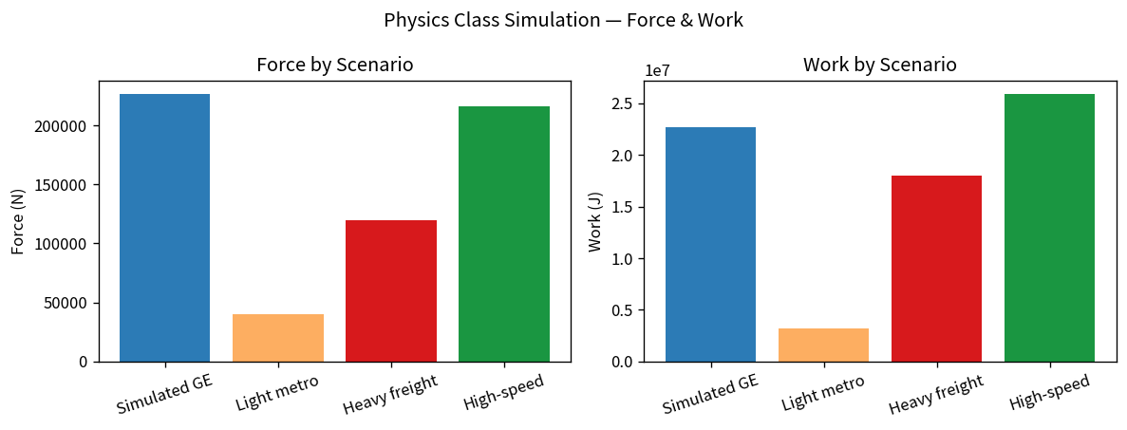
Figure: Force (left) and Work (right) under four different train scenarios.

Key Takeaways
- Function composition is powerful: get_work simply re-uses get_force, illustrating DRY design even in a short teaching script.
- Default arguments (c = 3×10⁸) make the energy function convenient while still allowing students to experiment with other values of c.
- Changing acceleration scales both force and work linearly; changing distance scales only work. The simulation cell makes this relationship immediately visible.
- Providing lambda / one-liner alternatives and extra practice (Kelvin, kinetic energy, gravity) gives stronger students a natural next step without overwhelming beginners.
- The companion notebooks follow the project style: a skeleton with step-by-step TODOs for practice, and a fully worked solution that also contains the flowchart, alternates, simulation and charts.

